From the College Home Page, users can find CSLOs, PSLOs, and ISLOs for every course.

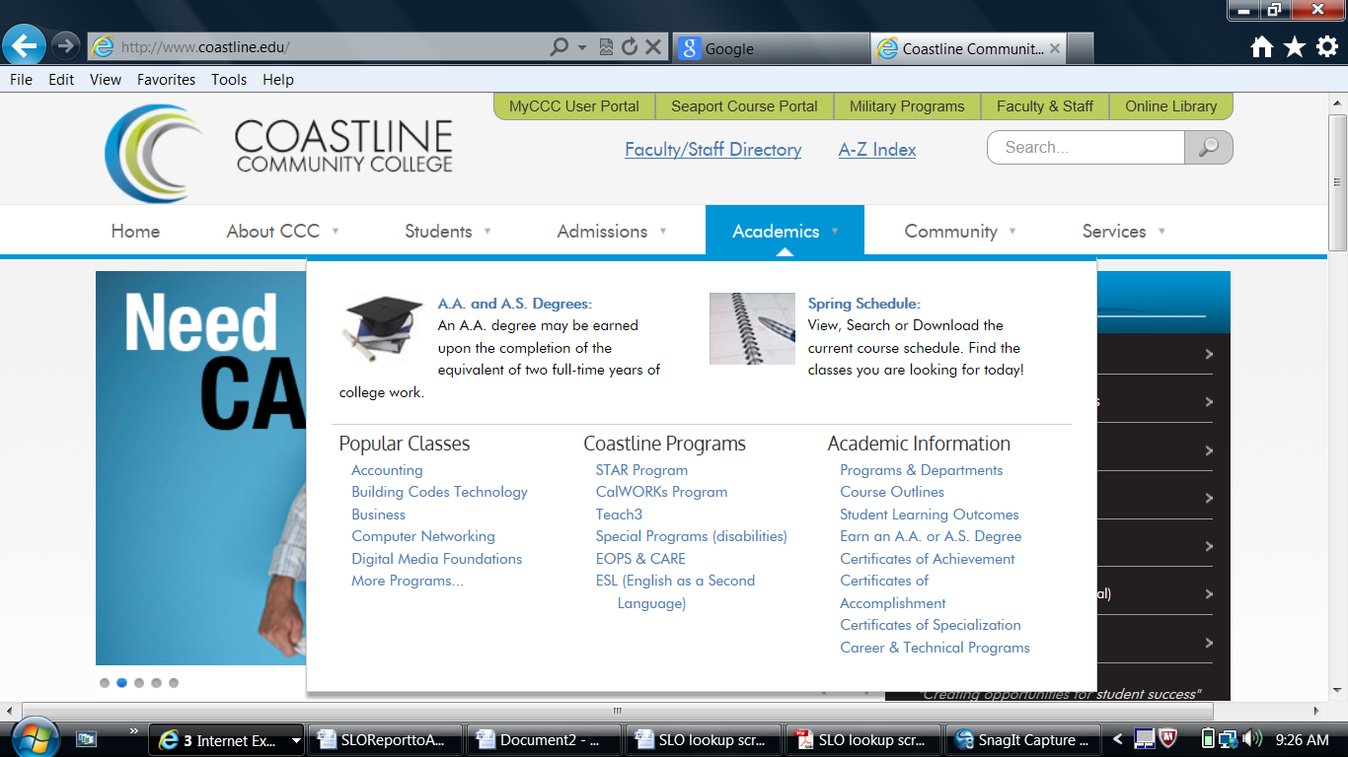

This screens shows options available from the SLO drop-down menu box.

